UNIVERSITY OF MINNESOTA

***Duluth Campus*** *Department of Studies in Justice, Culture, and Social Change* *228 Cina Hall*

*College of Arts, Humanities, and Social Sciences*  *1123 University Drive*

*Duluth, Minnesota 55812-3306*

*E-mail:* [*troufs@d.umn.edu*](mailto:troufs@d.umn.edu)

*ZOOM:* [*https://umn.zoom.us/my/troufs*](https://umn.zoom.us/my/troufs)

*13 October 2024*



f2024 [*Week 8 Module*](https://canvas.umn.edu/courses/468530/modules/1955783)

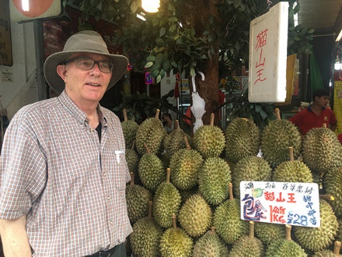

[Tim Roufs,](http://www.d.umn.edu/~troufs/#title) Singapore Market, 2017

**Anthropology of Europe Week 8**

**What’s Happening Week 8?**

* + - * + **READ AND WATCH**

**READ TEXT . . .**

**VIEW SLIDES**

**WATCH VIDEO**

**Watch Video Clips**

**IN-THE-NEWS**

* + - * + **MIDTERM EXAM**
        + **DISCUSSION**
        + **PROJECT**
        + **OTHER**

**EXTRA CREDIT**

**FOR FUN TRIVIA** (optional)

**LIVE CHAT**(optional)

Tuesday 7:00-8:00 p.m.

* + - * + **QUESTIONS / COMMENTS / SUGGESTIONS**
        + **WRAP-UP**

[click ↑ here]

# What’s Happening Week 8?

**This week take a little time to go over your Midterm exam—with an eye on the Final Exam. Going over the Midterm oftentimes helps when it comes to preparing for the Final Exam. If you have any questions or comments please let me know.**

**Ireland**

**This week we’re headed off to the Emerald Isle, one of the most beautiful places on earth. Our introduction to Ireland, as it was for Greece, is with one of the great classic films of all times, Robert Flaherty’s *Man of Aran*. Then, in one of the unique events in ethnocinematography, we’ll spend an hour visiting years after with the locals who were featured in *Man of Aran*, as well as their neighbors who are not so famous. In "How the Myth was Made" we have a retrospective look at Flaherty’s work, and let the locals explain its meaning.**

**And we follow up these classic videos with slide decks featuring . . .**

1. **the Aran Islands, off the coast of Galway,**
2. **the western and southern coasts around (a) The Dingle Peninsula, (b) The Ring of Kerry—home of the famed Kerrymen—and (c) Cork—usually the main town on your way to kiss the Blarney Stone at the Blarney Castle, and**
3. **Newgrange—a site like Stonehenge only a thousand years older than Stonehenge, and five hundred years older than the great pyramid of Giza in Egypt.**

**And finally, schedule in some time blocks to work on your Project, after you complete a brief Student Survey.**

## Read and Watch Week 8

### READ THE TEXTBOOK FOR WEEK 8

[Textbook Information](http://www.d.umn.edu/cla/faculty/troufs/anthfood/aftexts.html#title)

[Readings for the Semester](https://www.d.umn.edu/cla/faculty/troufs/anthfood/afread-s.html#title)



REM: Links on screenshots are not “hot” (active)

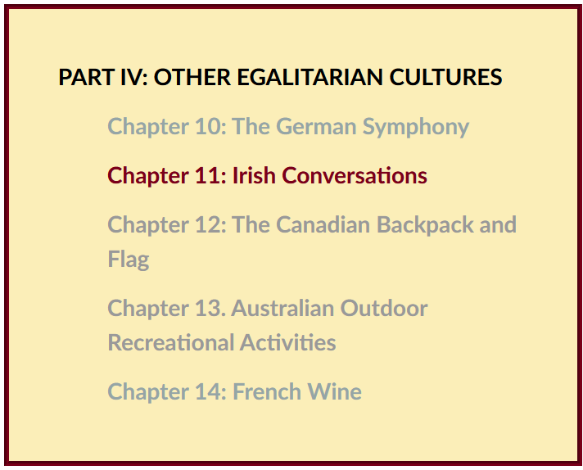f

### VIEW THE SLIDES FOR WEEK 8

[Class Slides for the Semester](http://www.d.umn.edu/cla/faculty/troufs/anthfood/afslides.html#title)

**Ireland: Introduction / Inis Oírr**

(aka Inish Beag)

(.[pptx](http://www.d.umn.edu/cla/faculty/troufs/anth1095/PowerPoint/Ireland_intro.pptx))

[click **↑** here]

**Ireland: Aran, Galway, Clare, Conamara**

(aka Inish Beag)

(.[pptx](http://www.d.umn.edu/cla/faculty/troufs/anth1095/PowerPoint/Ireland_Aran_Galway_Clare_Conamara.pptx))

[click **↑** here]

**Ireland: Dingle, Kerry, Bantry, Cork . . .**

(.[pptx](http://www.d.umn.edu/cla/faculty/troufs/anth1095/PowerPoint/Ireland_Dingle_Kerry_Bantry_Cork.pptx))

[click **↑** here]

**Ireland: Newgrange**

(.[pptx](http://www.d.umn.edu/cla/faculty/troufs/anth1095/PowerPoint/Ireland_Newgrange.ppt))

[click **↑** here]

***Slán agat* IRELAND**

**We’ll finish our Ireland materials with the slides from** [**Inish Óirr**](http://en.wikipedia.org/wiki/Inisheer) **(aka *Inish Beag*), the smallest of the three well-known Aran Islands. We’ll visit the knitters of the famous “Irish Fisherman Sweaters”, and have a look around the island, and “the mainland”, before we have a brief look at Newgrange and say *Slán agat*.**

[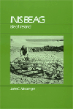](http://www.d.umn.edu/cla/faculty/troufs/anth3635/cetexts.html#InisBeag)

The full Ireland slide sequence,

should you want to look at the other slides, includes . . . .

* **Introduction /** [**Inis**](http://www.irelandforvisitors.com/articles/aran_islands.htm)[**Oírr**](http://www.irelandforvisitors.com/articles/aran_islands.htm) slides: (.[pptx](http://www.d.umn.edu/cla/faculty/troufs/anth1095/PowerPoint/Ireland_intro.pptx))
* **Aran, Galway, Clare, Conamara . . .** slides: (.[pptx](http://www.d.umn.edu/cla/faculty/troufs/anth1095/PowerPoint/Ireland_Aran_Galway_Clare_Conamara.pptx))
* **Dingle, Kerry, Bantry, Cork . . .** slides: (.[pptx](http://www.d.umn.edu/cla/faculty/troufs/anth1095/PowerPoint/Ireland_Dingle_Kerry_Bantry_Cork.pptx))
* **Dublin . . .** slides: (.[pptx](http://www.d.umn.edu/cla/faculty/troufs/anth1095/PowerPoint/Ireland_Dublin.pptx))
* **Newgrange . . .** slides: (.[pptx](http://www.d.umn.edu/cla/faculty/troufs/anth1095/PowerPoint/Ireland_Newgrange.pptx))
* **Analysis . . .** slides: (.[pptx](http://www.d.umn.edu/cla/faculty/troufs/anth1095/PowerPoint/Ireland_analysis.ppt))

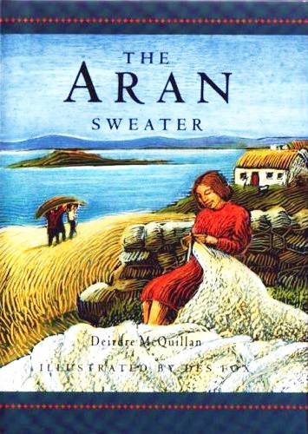

[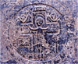](http://irishislands.info/oilphoto/Aran/InisOirr/105teampallc2_jpg.html)

[Inish Óirr](http://en.wikipedia.org/wiki/Inisheer)

[Ireland](http://www.d.umn.edu/cla/faculty/troufs/anth1095/Ireland.html#title)

### WATCH THE VIDEO EXPLORATIONS FOR WEEK 8

Real People . . . Real Places . . .

[Videos for the Semester](https://www.d.umn.edu/cla/faculty/troufs/anthfood/afvideo_schedule.html#title)

**Ireland**

**One of the great films of all time is Robert Flaherty’s *Man of Aran***. It’s a classic, from just this side of silent movie days. *Man of Aran* is also a **“Master Text”** for Ireland and for Anthropology of Europe as a whole. *Man of Aran* did almost *all* of those things “Master Texts” and “Classics” are supposed to do—including create lasting images that become the popular conceptions of a people, and **it formulated the people as myth**.

We’ll first have a look at *Man of Aran*, and then we’ll listen to what the Aran Island people have to say about “their” iconic film. Some of the very same people who “starred” in *Man of Aran*—will tell you what *they* think, in **“How the Myth Was Made”.**

And after we’ve had a chance to see *Man of Aran* and *How the Myth Was Made* this week, we’ll take a walk around ***Inis Óirr*** (*Inish Beag* to John C. Messenger) and many other parts of the Emerald Isle after Spring Break.

First we’ll have a look at Robert Flaherty’s Film Classic, and Master Text

 ***Man of Aran***  
(77 min, 1934, B&W)

**Ireland**

**One of the great films of all time is Robert Flaherty’s *Man of Aran***. It’s a classic, from just this side of silent movie days. *Man of Aran* is also a **“Master Text”** for Ireland and for Anthropology of Europe as a whole. *Man of Aran* did almost *all* of those things “Master Texts” and “Classics” are supposed to do—including create lasting images that become the popular conceptions of a people, and **it formulated the people as myth**.

We’ll first have a look at *Man of Aran*, and then we’ll listen to what the Aran Island people have to say about “their” iconic film. Some of the very same people who “starred” in *Man of Aran*—will tell you what *they* think, in **”How the Myth Was Made”.**

And after we’ve had a chance to see *Man of Aran* and *How the Myth Was Made* this week, we’ll take a walk around ***Inis Óirr*** (*Inish Beag* to John C. Messenger) and many other parts of the Emerald Isle after Spring Break.

First we’ll have a look at Robert Flaherty’s Film Classic, and Master Text

***Man of Aran***  
(77 min, 1934, B&W)

[**on-line access**](https://video-alexanderstreet-com.libpdb.d.umn.edu:2443/watch/man-of-aran)

[click **↑** here]

Alexander Street

 [**New UMD Link for *Man of Aran***](https://primo.lib.umn.edu/permalink/f/1np6bfs/UMN_ALMA51813690360001701)

via AVON 2023.05.12

[New UMD Link for Man of Aran](https://primo.lib.umn.edu/permalink/f/1np6bfs/UMN_ALMA51813690360001701)  
old link expires 12/07/2023

[**course viewing guide**](https://www.d.umn.edu/cla/faculty/troufs/anth3635/video/Man_of_Aran.html#title)

[Aran Islands](https://www.d.umn.edu/cla/faculty/troufs/anth3635/video/Man_of_Aran.html#title), [Ireland](https://www.d.umn.edu/cla/faculty/troufs/anth1095/Ireland.html#title)

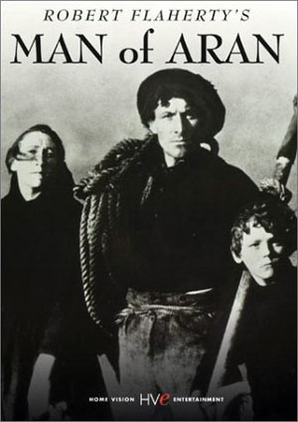

(UM Duluth Martin Library Multimedia DA990.A8 M37 2003 DVD)

*Man of Aran* created lasting images and formulated the insular people of Ireland as a popular myth.

What do the people of the Aran Islands think about that?

We’ll see about that in

**"How the Myth was Made"**

(60 min, 1978)

 [**on-line access**](https://video-alexanderstreet-com.libpdb.d.umn.edu:2443/watch/how-the-myth-was-made?context=channel:anthropology)****

[click ↑ here]

Alexander Street

[**viewing guide**](https://www.d.umn.edu/cla/faculty/troufs/anth3635/video/Man_of_Aran.html#title)****

(UM Duluth Martin Library Multimedia DA990.A8 M37 2003 DVD)

**“. . . The work of anthropologists is not only to invent, explore, and make useful the general concept of ‘culture’ but also to invent particular cultures”**

-- Roy Wagner (1975), quoted in Susan Parman,

[*Europe in the Anthropological Imagination*](http://www.d.umn.edu/cla/faculty/troufs/anth3635/cetexts.html#AnthropologicalImagination) (1998), p. 2

"How the Myth was Made" is a sixty minute documentary about the making of *Man of Aran*, where you will see the actors themselves reflect on the film, and find out what their neighbors think about it.

A little later we’ll visit [Inish Óirr](http://en.wikipedia.org/wiki/Inisheer) (aka *Inish Beag*), the smallest of the three Aran Islands. We’ll visit the knitters of the famous “Irish Fisherman Sweaters”, and have a look around the island, and “the mainland”, before we say *Slán agat*.

[](http://www.d.umn.edu/cla/faculty/troufs/anth3635/cetexts.html#InisBeag)

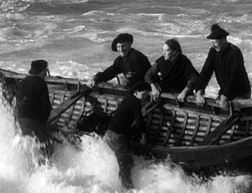

Scene from Man of Aran

**WATCH THE VIDEO CLIPS FOR WEEK 8**

**Watch Video Clip**

[Class Slides for the Semester](http://www.d.umn.edu/cla/faculty/troufs/anthfood/afslides.html#title)

**IN-THE-NEWS WEEK 8**

Media Bias Chart

Fake News

Sign Up in your Course [Google Drive](https://canvas.umn.edu/courses/259075/external_tools/880) Folder:

f2024 <https://docs.google.com/document/d/1IlkUMRHy7ZPeIbxYelRuFGw4Vc5ZwXwv1e-qKEgDDvk/edit?usp=sharing>

[click **↑** here]

[**REM: "Fake News"? / Media Bias? / "Alternative Facts"? (Helpful Chart)**](https://canvas.umn.edu/courses/282731/modules/items/6597860)****

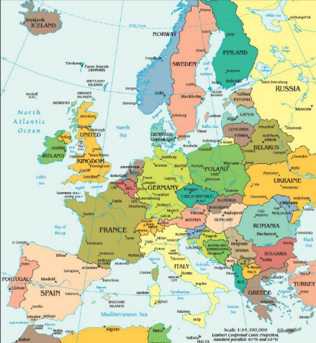

[**Ireland**](https://www.d.umn.edu/cla/faculty/troufs/anth1095/Ireland.html#project_sources) **– tba**

**MIDTERM EXAM . . .**

General Midterm Exam Information

**Brief Review of Midterm Exam**

**If you took the exam, check for the results are in your  Gradebook (check the left-hand Course Navigation column on your “Home” page).**

**Then take a little time to go over your Midterm exam—with an eye on the Final Exam. Going over the Midterm oftentimes helps when it comes to preparing for the Final Exam. If you have any questions or comments please let me know.**

|  |
| --- |
| REM: Links on screenshots are not “hot” (active) |

Set your “Arrange By” preferences in your  Gradebook:

|  |
| --- |
| REM: Links on screenshots are not “hot” (active) |

**Profs “grading” exams is a lot like an ump in Major League Baseball calling balls and strikes.** The Major League rules are clear <<http://www.d.umn.edu/cla/faculty/troufs/anth3635/cegrades.html#strikezone>> as are the stated criteria for written projects and exams <[http://www.d.umn.edu/cla/faculty/troufs/anth3635/cegrades.html#title](http://www.d.umn.edu/cla/faculty/troufs/anth3635/cegrades.html#strikezone)>.

But, in the end, they are both human judgments.

The biggest difference between a Major League Umpire calling balls and strikes and a professor calling a grade is that you jet ejected from the baseball game if you are argue balls and strikes (see Section 9.02 Official Baseball Rules <<http://mlb.mlb.com/mlb/official_info/official_rules/foreword.jsp>> and one ***should*** really question the prof if they didn’t like the call, and that is especially true for midterm exams as one can often learn quite a bit that is helpful for the Final Exam by looking over and discussing a midterm exam.

Maybe a better analogy would be judging **Olympic Figure Skating, or Gymnastics, or Ski Jumping, Diving** and the like . . . <<http://www.d.umn.edu/cla/faculty/troufs/anth3635/cegrades.html#gymnastics>>.

If your style is to look at charts, the grading “chart” is at<<http://www.d.umn.edu/cla/faculty/troufs/anth3635/cegrades.html#gradingpolicies>>.

So if, for whatever reason, you didn’t like “the call,” e-mail.

**Please pay attention to what the numbers mean** in terms of the final course letter grade. Click **“View Rubric”** on the exam page for details.

|  |
| --- |
| REM: Links on screenshots are not “hot” (active) |

### DISCUSSION FOR WEEK 8

[Online Discussions Information, Rubric, and Sample Posts](https://www.d.umn.edu/cla/faculty/troufs/anthfood/afforumsamples.html#title)

**PROJECT INFORMATION . . .**

Basic Information

Main Due Dates

[**Schedule Some Time Blocks to Work on Your Class Project**](https://canvas.umn.edu/courses/282731/modules/items/6597883)

**Project Time Blocks**

If you haven’t already done so, ***schedule* some serious time blocks to work on your Project**. And be sure to ask if you have any questions about your Promissory Abstract, your Working Bibliography, or even about your Proposal itself.

One thing you should already have **started to think about is how you might present your findings**. Generally it is a good idea to pretty much finish your paper before you do too much work on your presentation, but, having said that, it is still a good idea to at least start thinking about what your presentation might be like.

### OTHER . . .

[Main Due Dates](https://www.d.umn.edu/cla/faculty/troufs/anthfood/afdue-dates.html#title)

f2024 [**Module Week 8**](https://canvas.umn.edu/courses/468530/modules/1955783)

[(optional) **Study Abroad? Explore the World? Do it. . . .**](https://canvas.umn.edu/courses/282731/modules/items/6597854)

**Take the Student Survey**

**For this week our course developer, has prepared an on-line survey of the class. Please help us by filling it out honestly, and promptly. Your views are very important in the future development of this course. The survey is part of our main “Assignments and Activities” of the week . . .**

 [**Student Survey**](https://ay13.moodle.umn.edu/mod/feedback/view.php?id=227956) **Feedback**

f2024 <<https://canvas.umn.edu/courses/450740/modules/items/12194495>>

[click **↑** here]

|  |
| --- |
| REM: Links on screenshots are not “hot” (active) |

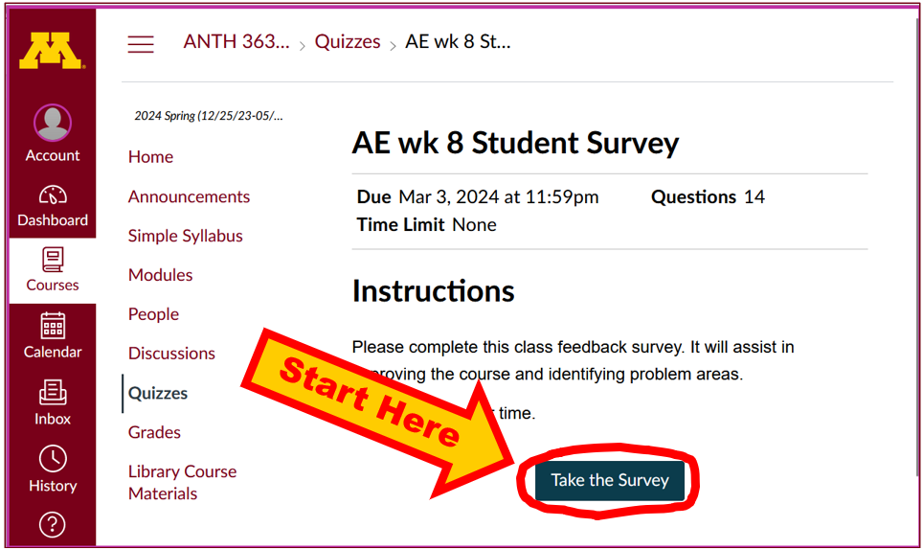

**Review . . .**

[OWL logo--Online Writing Lab, Purdue University](http://owl.english.purdue.edu/owl/)

[**Writing Essays for Exams**](https://owl.purdue.edu/owl/general_writing/common_writing_assignments/essays_for_exams.html)

If you have any questions about the [Final Exam](http://www.d.umn.edu/cla/faculty/troufs/anthfood/afexams_final.html#title), please let me know, or bring them up in.

(optional) **EXTRA CREDIT . . .**

[Basic Extra Credit Information](https://www.d.umn.edu/cla/faculty/troufs/anth1095/gcextracredit.html#title)

Extra Credit is available in this class.

We’ll have a closer look at Extra Credit after the Midterm Exam.

Be sure to check the details of the **activities and assignments** each week in your folder.

If you didn’t do quite as well as you might have liked on the Midterm Exam, or if you did better than you even hoped on the Midterm exam but want to “bank” some insurance points for your final course grade, think about doing one (or even two—one of each) of the optional extra credit papers.

There are **two Extra Credit options:** **(A) a case study**, and/or **(B) a review of a lecture or event, or an approved film** (*other* than one of the films we see in class). For the review option you may also *compare* two or more films. (Remember from Week 1, one of the main features of anthropology is that it is *comparative*?)

**Details on the extra credit** are on-line at

<<http://www.d.umn.edu/cla/faculty/troufs/anth3635/extra_credit/ceextracredit.html#title>>

#### **FOR FUN TRIVIA** (optional)

[Food Trivia HomePage](https://www.d.umn.edu/cla/faculty/troufs/anthfood/trivia/aftrivia.html#title)

#### **LIVE CHAT OPEN FORUM / OFFICE HOURS . . .** (optional)

Tuesday 7:00-8:00 p.m. (CDT) On ZOOM

[Contact Information](http://www.d.umn.edu/cla/faculty/troufs/anth1602/pcoffice.html#title)

**“**[**ZOOM**](https://umn.zoom.us/my/troufs)**”**

[click **↑** here]

or

e-mail anytime:<mailto:troufs@d.umn.edu>

[click **↑** here]

Live Chat is optional.

#### **QUESTIONS? / COMMENTS / SUGGESTIONS . . .**

If you have any questions or commentsright now, please do not hesitate to post them on the **[](http://canvas.umn.edu/)** “Discussions”, or e-mail [troufs@d.umn.edu](mailto:troufs@d.umn.edu), or ZOOM <https://umn.zoom.us/my/troufs>. (E-mail is fastest, and most generally best as quite often URLs need be sent.)

Best Wishes,

Tim Roufs

<[http://www.d.umn.edu/~troufs/](http://www.d.umn.edu/%7Etroufs/)>

<<https://umn.zoom.us/my/troufs>>

<[other contact information](http://www.d.umn.edu/cla/faculty/troufs/anth1602/pcoffice.html#title)>